 | REPUBLIC OF THE MARSHALL ISLANDS  MARITIME ADMINISTRATOR
APPLICATION FOR PRIVATE YACHT UNDER 24 METERS

DESIRED PORT OF REGISTRY (SELECT ONE): JALUIT BIKINI

PART 1. GENERAL
NEW NAME |  |  | PRESENT NAME
PRESENT COUNTRY OF REGISTRY |  | YACHT TYPE |  |  | EXPECTED DATE OF REGISTRATION
 |  | Sail Motor
NAME OF REGISTERED OWNER | DOMICILE / ADDRESS (full address) |  |  | CITIZENSHIP |  | OWNERSHIP %

PART 2. YACHT PARTICULARS
BUILT BY |  |  |  | HULL NO. | YEAR BUILT |  | PLACE BUILT (City, Country)
KEEL LAYING DATE |  | TOTAL PROPELLING POWER |  |  | LENGTH OVERALL (LOA)
 |  | KW |  |  | (in Meters)
LENGTH | BREADTH |  | DEPTH |  |  | GROSS TONS |  | NET TONS
(in Meters) | (in Meters) |  | (in Meters)

PART 3. CONTACT

Company Name:

Address: Telephone: Email:
Name of Designated Person (DP): First Name: Last Name:
Telephone: 24-hour Mobile Telephone: DP Email:

Name of Alternate Designated Person: First Name: Last Name:
Telephone: 24-hour Mobile Telephone: Email:

PART 4. BILLING PARTICULARS
Billing (including maritime and tonnage tax) post registration will be addressed according to the following information. NOTE: The registered owner’s name is automatically printed on the first line of all vessel related invoices. Check if invoices are required in hard copy (invoices will be conveyed via e-mail unless otherwise specified).
Billing Company:
Attention:
Address:

Telephone:
Email:
Email:

PART 5. INSTRUMENT RECORDATION
Do you intend to record a mortgage builder’s certificate bill of sale

PART 6. DECLARATION OF PRIVATE USE (NOT FOR HIRE)
I, the undersigned, on behalf of the owner of the yacht described in Parts 1 above, registered or to be registered in the Republic of the Marshall Islands (RMI), swear and affirm that such is a pleasure yacht which will hold a Private Yacht Certificate of Registry and comply with the requirements of a Private Yacht as defined in the RMI Maritime Regulations (MI-108); and further:
- That said yacht will not be offered for any type of charter operation or be engaged in trade for the transportation of merchandise or the carriage of passengers for reward, remuneration, or gain regardless of any voluntary compliance indicated below.
- That the required third-party liability insurance coverage and hull and machinery insurance coverage is in place and will be maintained.
- That the owner agrees to maintain compliance with all applicable international requirements and the RMI Yacht Compliance Requirements (MI-103A).
- That private yachts of less than 24 meters in length, the owner confirms that the following will be complied with at all times:
  - the yacht will carry, and maintain within the applicable service windows, lifesaving appliances sufficient to cover all persons onboard;
  - the firefighting equipment carried onboard and all fire detection and alert systems are in good working condition and will be maintained as required and within the applicable service windows; and
  - the international and coastal State requirements, applicable to the size and gross tonnage of the yacht, are complied with as applicable.
- That the owner understands that in the event of the sale of the yacht or the interest in the owning entity, the purchaser will have no automatic right to re-register the yacht in their ownership or to continue registration of the yacht under the RMI flag.
- That the owner understands that if it is determined that this Declaration has been deliberately and fraudulently filed, the Maritime Administrator may immediately terminate the Private Yacht Certificate of Registry and strike the yacht from the RMI registry at its sole discretion..

PART 7. OATH OF OWNER OR AUTHORIZED AGENT

I, |  | , a citizen of |  | ,
hereby swear and affirm, in accordance with Section 209(1) of the Republic of the Marshall Islands (RMI) Maritime Act, that I am a duly authorized agent or officer of the owner(s), managing owner(s), or part owner(s) of the yacht as described in Part 1 herein and declare that all information contained in Parts 1 through 7 herein are true and correct and that, pursuant to Section 214(1) of the RMI Maritime Act, the Master has been ordered and instructed, upon receipt of the yacht’s RMI Certificate of Registry, to make the markings required by Section 230 of the RMI Maritime Act, and when transferring from another flag, to surrender the yacht’s documents issued by the Government of the Present Country of Registry as declared in Part 1 herein. I swear and affirm that the vessel will not be present in the waters of an embargoed nation⁵ at time of registration.

⁵ For the purposes of this document embargoed nation shall include Iran, Syria, Cuba, North Korea, and the Donbas and Crimea regions of Ukraine.

Subscribed and Sworn Before me
this | day of | 20
at | (SIGNATURE)
SIGNATURE OF NOTARY PUBLIC, OR OTHER OFFICER AUTHORIZED BY RMI LAW TO ADMINISTER OATHS |  | (TITLE)

A copy of this page shall be kept onboard the yacht at all times

LENGTH, BREADTH AND DEPTH OF PRIVATE YACHTS UNDER 24 METERS

Length Overall (LOA) is the distance from the forward side of the stem to the aftermost side of the stern. This does not include bolt on items such as swim platforms, pulpits or anchor equipment.

Breadth – the maximum width of the yacht not including bolted on rubrails and other items.

Depth – the maximum depth of the yacht measured in meters vertically from the top of the deck at the side to the underside of the hull where it meets the keel. The Depth does not equal the draft.

Length – Load Line Length as defined by the International Convention of Load Lines, 1988.

Shall be listed for yachts with LOA over 24m as:
    - Load Line Length if known.
    - Hull Length as defined by the vessel’s CE certificate.
    - Waterline Length.

Shall be listed for yachts whose LOA is under 24m:
- The LOA

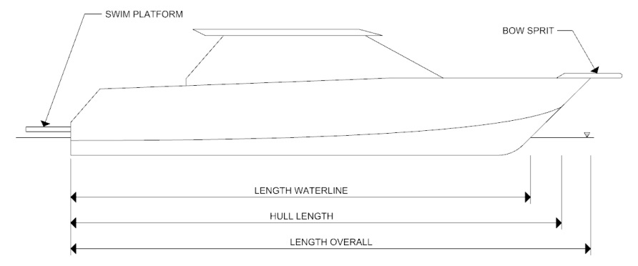
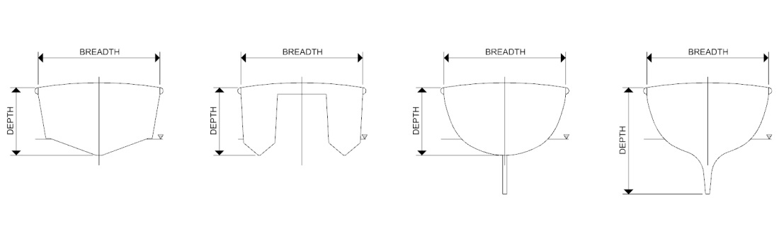

If more than one (1) Registered Owner, please attach an extra sheet.
See page 3 MI-101U guidance for definition of length, breadth and depth.
The Designated Person must be shore based and available for direct and immediate contact by the Administrator on a 24-hour basis for matters relating to vessel operations, marine safety, security and protection of the marine environment
Required for re-registration.

