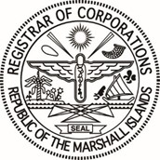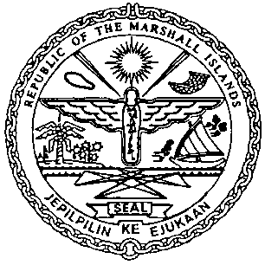
REPUBLIC OF Corporate Memo
THE MARSHALL ISLANDS
No. 01-26
REGISTRAR OF CORPORATIONS
May/2026

To: All Relevant Parties
Subject: New Look for Hard Copy Certificate of Goodstanding
References: N/A
Purpose
The purpose of this Corporate Memo is to inform all relevant parties of the change in the look of the standard hard copy Certificate of Goodstanding issued by the Registrar of Corporations of the Republic of the Marshall Islands. Effective May 4, 2026, the below key changes will take effect.
Key Changes
- The Certificate of Goodstanding will be printed on standard quality bond paper, replacing the custom cream paper.
- The document may be printed on US standard letter size paper (8.5 x 11 inches) or A4 international standard size paper (8.27 x 11.69 inches).
- A single border line will frame the document instead of the thick-thin double line border.
- A gray watermark of the Republic of the Marshall Islands seal will be visible, together with the official stamp, signature, and issuance details of the Deputy Registrar.
- A unique tracking number will be added to enhance security and enable online verification.

Due to the electronic generation of the document and its unique tracking number, it may serve as an alternative electronic Certificate of Goodstanding (E-CGS) to the current electronic and QR Code verifiable E-CGS already in use by the Registrar of Corporations. Questions concerning the changes to the look of the standard hard copy Certificate of Goodstanding may be directed to corp@register-iri.com.

